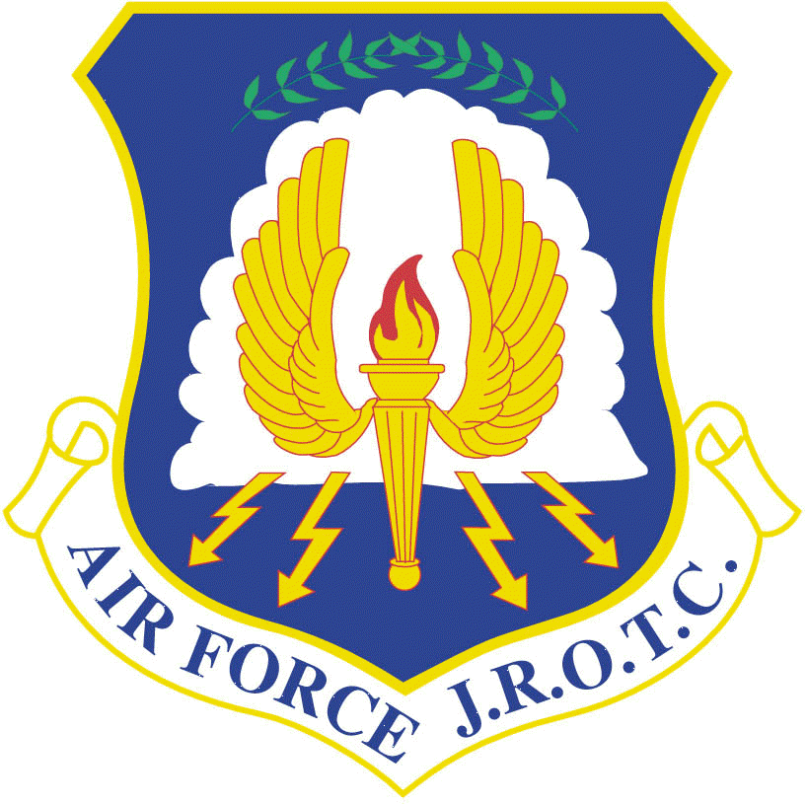
Air Force Junior Reserve Officer Training Corps (AFJROTC)
Course Syllabus – GA-20051
Academic Year 2018 – 2019
East Paulding High School

Senior Aerospace Science Instructor (SASI) – Lt Col Mike Farr, USAF, (Ret)
mfarr@paulding.k12.ga.us

Aerospace Science Instructor (ASI) – Master Sergeant Jim Greene, USAF, (Ret)
jgreene@paulding.k12.ga.us

Aerospace Science Instructor (ASI) – Master Sergeant Stan Parker, USAF, (Ret)
sparker@paulding.k12.ga.us

Course Name: AFJROTC I

The Mission of Air Force JROTC is to develop citizens of character dedicated to
serving their nation and community.

Credit Hours: One elective credit per semester.

Supplies: Each cadet will have access to a Cadet Guide that outlines all requirements for successful completion of the AFJROTC program (located in each classroom and on AFJROTC website—www.ephsafjrotc.com). See the Cadet Guide for detailed information on classroom procedures, conduct and behavior expectations. Cadets will bring notebook paper and a pencil/pen to class every day (electronic devices are permitted for note taking upon being granted permission by instructor). Furthermore, cadets will be required to wear their Air Force JROTC uniform to school as directed by the SASI.

Overview: The success of the AFJROTC program lies in its progressive and academically sound curriculum and the extra-curricular activities AFJROTC offers students. The curriculum is two part:

- The Leadership Education 100, Traditions, Wellness, and Foundations of Citizenship (LE) portion will introduce cadets to history, organization, mission, traditions, goals, and objectives of JROTC for all services. It introduces key military customs and courtesies, how to project a positive attitude, and will exam the principles of ethical and moral behavior. It provides strategies for effective note taking and study skills for academic success. Lessons will cover how to be emotionally, mentally, and physically healthy. Avoiding and preventing violence in today’s society will also be covered. How to recognize types of bullying and how to advocate for prevention of this type of behavior. It will cover healthy living, physical fitness, and how to make safe, drug-free, and responsible decisions. Approximately 72 classroom hours will be dedicated towards the Leadership Education curriculum.

  - Required Text: Leadership Education I: Traditions, Wellness, and Foundations of Citizenship, 2015.

  - Fall Semester, Plan of Study
Chapter 1 – Introduction to JROTC Programs
Chapter 2 – Personal Behavior
Chapter 3 – Be Health Smart

  - Fall Semester, Plan of Study
Chapter 4 – Making Safe, Drug-Free Decisions
Chapter 5 – The Foundations of United States Citizenship

- The Aerospace Science, A Journey into Aviation History (AS) portion is an aviation history course focusing on the development of flight throughout the centuries. It starts with ancient civilizations, then progresses through time to modern day. The emphasis is on civilian and military contributions to aviation; the development, modernization, and transformation of the Air Force; and a brief astronomical and space exploration history. Approximately 72 classroom hours will be dedicated towards the Aerospace Science curriculum.

  - Required Text: A Journey into Aviation History, 2007

  - Spring Semester, Plan of Study
Unit 1: Imagining Flight
Chapter 1 – Ancient Flight
Unit 2: Exploring Flight
Chapter 2 – Pioneers of Flight
Chapter 3 – Expanding the Horizon

  - Spring Semester, Plan of Study
Unit 3: Developing Flight
Chapter 4 – The Early Air Force
Chapter 5 – Commercial Flight
Chapter 6 – The Modern Air Force
Unit 4: Extending Flight
Chapter 7 – Astronomy and Space
Chapter 8 – Exploring Space

- Drill and Wellness: Approximately 36 classroom hours will be dedicated towards the Drill and Wellness curriculum. Required Text: AF Manual 36-2203, Personnel Drill and Ceremonies, V-2627.

COURSE OBJECTIVES AND GOALS:

Journey into Aviation History:
1. Know the historical facts and impacts of the early attempts to fly.
2. Know the major historical contributors to the development of flight.
3. Know the contributions of the U.S. Air Force to modern aviation history.
4. Know the key events of space exploration history.

Leadership Education 100: Traditions, Wellness, and Foundations of Citizenship
1. Analyze the heritage, organization, and tradition of service programs.
2. Analyze the benefits of positive personal behavior.
3. Evaluate healthy living through physical activity and good nutrition.
4. Apply safe, drug-free decisions.
5. Analyze the importance of citizenship in the United States.

Drill & Ceremonies
1. Know the importance of drill and ceremonies.
2. Know basic commands and characteristics of the command voice.
3. Apply and execute the concepts and principles of basic drill positions and movements.
4. Know when and how to salute.
5. Apply the principles and procedures of drill movements used with smaller units to the movement of a squadron.
6. Know the function of the group and the wing.
7. Know how groups and wings are formed.
8. Know the purpose and definition of ceremonies and parades.

Wellness and Physical Fitness
1. Create an individualized training program based on national standards by age and gender.
2. Identify areas of improvements for each cadet and provide guidance for improvement.
3. Incorporate a physical training program to reach fitness goals.

Environment:

Our goal in AFJROTC is to create an atmosphere for learning and leadership development. Program success requires students to act responsibly to the military environment and to embrace the Air Force core values, “Integrity, Service Before Self, and Excellence In All We Do.” Any behavior that keeps a student from learning, disrupts the class, or causes an unsafe condition, will not be tolerated. We will notify parents/guardians when their student exhibits poor work, a poor attitude, or refuses to properly wear the AFJROTC uniform. Students are expected to comply with the standards outlined in the Cadet Guidebook, to include following the instructions of the senior cadets in the AFJROTC organization.

UNIFORM DAY: Cadets are required to wear the AFJROTC uniform every WEDNESDAY. If absent, then wear the uniform the next day upon return to school or receive a permanent grade of “0.” A temporary grade of zero will be loaded into the gradebook upon absence but will be changed if the uniform is worn upon return to school. Cadets are required to wear their Physical Training uniform every FRIDAY. If absent, then cadets have one week to make-up missed PT training or receive a permanent grade of “0.” Any changes to the military uniform or PT uniform day will be briefed to all cadets in advance during their flight formation.

Safety:

A qualified instructor will carefully monitor all sanctioned AFJROTC activities. Although most activities are in a classroom or drill area, we will slowly incorporate group leadership projects and physical fitness into the program. All students enrolled in the AFJROTC program must meet the same physical fitness criteria as required for any EPHS physical fitness program.

Course Grading Criteria/Policy:

All cadets earn their grades based on their performance in the AS and LE curriculum. Grades will not be awarded to a cadet for merely attending classes. All points earned will be on a scale of 0 to 100 and incorporated into the EPHS grading system with the following percentages.

Grading Scale: A = 90 – 100; B = 80 – 89; C = 70 – 79; F = 69 and below/failing with no credit.

Uniform *(see below) 25%

Formal Drill Grade 5%
Summative Grades 71%
Leadership/Followership *(see below) 10%
Cumulative Assessments, 31%
Tests and/or Research Project

Daily Activity, Article Reviews
Quizzes & Physical Fitness Participation 29% Formative Grades 29%

Final Exam 20%

Total Grade 100%

Note: Some grades will be loaded that represent student progress towards a learning goal, such as homework, practice activities, notebook checks, and class discussions. These grades are not a measure of student learning and are therefore not assigned a grade weight.

* Wear of the Air Force uniform is MANDATORY. Failure to wear the uniform on designated days will result in a summative grade of zero for that “Uniform Wear”; and, a failing summative grade in “Leadership/Followership” (during the applicable month) for not following instructions. Also, cadets not in uniform on designated days will be sent to ISS for that class period.

0% Informal Grades 0%

